

|  |
| --- |
|  |

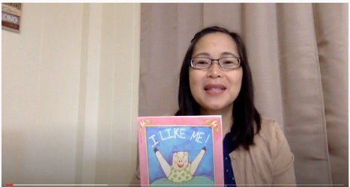

[Mrs. Shibuya- I Like Me!](https://www.youtube.com/watch?v=t5rpnaP3CHA)

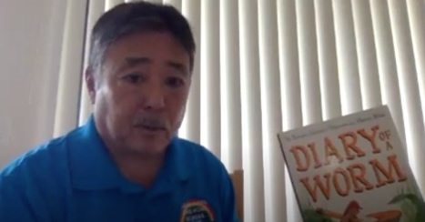

[Mr.Ohira- Diary of a Worm](https://www.youtube.com/watch?v=kAAryEoxfDs&t=1s)

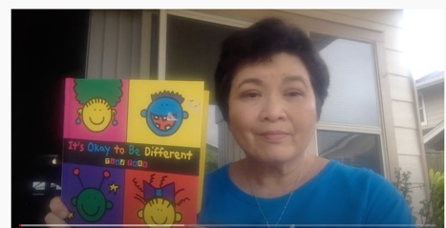

[Ms. Karen- It's Okay to be Different](https://www.youtube.com/watch?v=aeTgxGQ5_lU)